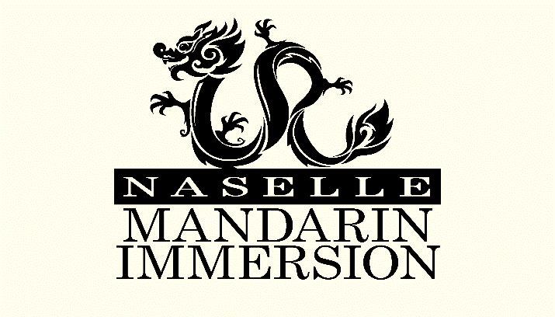

January 2016

Dear Community Member,

As the New Year is upon us, it is time to begin preparing to celebrate the Chinese New Year. For the second year, the Naselle Mandarin Parents Group, Liu Xing, is planning a community wide Chinese New Year Celebration. This year the celebration will take place Saturday, February 20, 2016 at the Rosburg School, and the parents group will be holding a silent auction during this event. One hundred percent of the proceeds from the silent auction will go to supporting the Naselle Mandarin Program, including teachers and students, field trips, and educational tools used in the classroom.
Today, we are contacting to ask if you are interested in participating by donating to this great cause. Generous donations include gift baskets, items that can be used to create gift baskets, gift certificates, and even cash donations. Anything you are able to contribute is greatly appreciated.
We hope that we can count on you to help support the amazing students of Naselle Elementary School. Please contact us to let us know how you might help. Any donations should be made by Saturday February, 13th . Donations can be dropped off at the Naselle school office or Azure Salon in Ilwaco. With your help we look forward to another successful event.

Come Join the Fun at Rosburg School
Celebrating the year of the Fire Monkey
Saturday February 20, 2016
Dinner will be served, games, silent auction and a Lion Dance to conclude the evening

Thank you and have a wonderful New Year!
Sincerely,
Naselle Mandarin Parents Group, Liu Xing
Like us on Facebook under Liu Xing
Support for this event was provided in part by the Teachers of Critical Languages Program’s Critical Language Project grant funds. The program is sponsored by the Bureau of Educational and Cultural Affairs of the U.S. Department of State (ECA), and administered by American Councils for International Education: ACTR/ACCELS.

