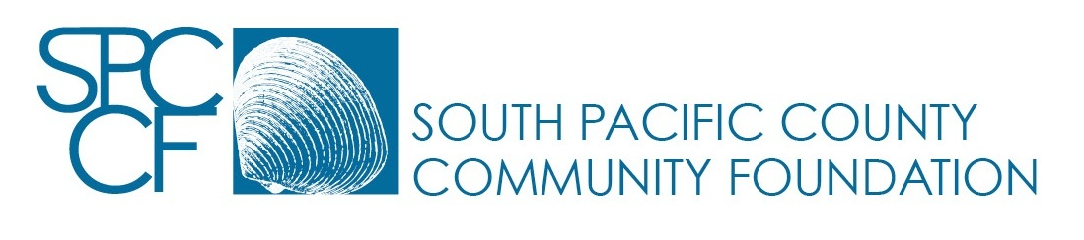
RISING STARS FUND CONTRIBUTION FORM

Name of the Fund: Rising Stars Fund
Purpose of the Fund: To support the Chinese Immersion Program at Naselle Elementary School

Amount of Contribution: _____________________________

Donor Name ____________________________________________

Address _______________________________________________________

City, State, Zip Code ______________________________________________

The Foundation MAY or MAY NOT announce publicly the Donor’s name and the fact of the Donor’s contribution. [Circle one]

Is the contribution pursuant to a pledge to the Foundation? Community foundations do not accept pledges, in keeping with guidelines established by the IRS. The correct answer is no. [Circle one]
YES NO

By signing this form, the Donor acknowledges that the contribution described in the form is irrevocably made to the Foundation and that the Foundation shall add the contribution to the Fund in accordance with and subject to the terms and provisions of the agreement establishing the Fund executed on December 10, 2014.

Donor’s Signature ____________________________ Date ________________

Return to: SPCCF, PO Box 75, Nahcotta WA 98637

Adopted July 14, 2014

